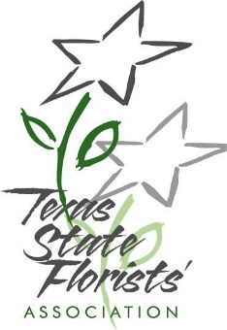
Creative Flair and National Certification Prep Course Registration Form
With Floriology Director of Education
Jackie Lacey AAF AIFD CFD PFCI

Schedule:
Saturday April 9, 2022 9:00 – 6:00 PM
Sunday April 10, 2022 9:00 – 6:00 PM
Monday April 11, 2022 9:00 – 2:00 PM

TSFA Member:
$899.00 – Course fee includes: Manual/Hard Goods/Fresh Flowers/Lunch Saturday – Monday
Dinner Saturday – Monday on your own

Non-Member:
$1089.00 – Course fee includes: Manual/Hard Goods/Fresh Flowers/Lunch Saturday – Monday
Dinner Saturday – Monday on your own

TOTAL: ______________

Name: ________________________________________________________________________

I wish to pay by: Check _______________ Credit Card __________________________________
Please make check payable to: Texas State Florists’ Association

Credit Card Information:

Card # ____________________________________ Exp: _____________ CVC Code: __________

Name on Card: _____________________________ Billing Zip: ____________________________

For more information, contact TSFA office at (512) 528-0806 or by email. Email registration forms
to txsfa@sbcglobal.net or mail to PO Box 859, Leander, TX 78646

Please bring your floral tools to class.

